

Software Requirement Specifications

FYP Team
Abdullah Bin Aqeel 21F-9215
Muhammad Abbas Hafeez 22F-3725
Ibrahim Muhammad Khan 22F-3707

Supervised by
Dr. Sahar Ajmal


Department of Computer Science
National University of Computer and Emerging Science
Chiniot, Pakistan
2025

Table of Contents
1. Introduction 5
2. Vision Document 6
2.1. Problem Statement 6
2.2. Motivation 6
2.3. Business Opportunity 7
2.4. Objectives 8
2.5. Scope 9
2.5.1 In Scope 9
Technical Scope 9
Non-Technical Scope 10
2.5.2 Out of Scope 10
2.6 Stakeholder and User Description 10
2.6.1 Market Demographics 10
2.6.3 User Environment 11
2.6.4 Stakeholder Profiles 12
3. System Requirement Specification 13
3.1 System Features 13
3.1.1 Core Platform and Trust 13
3.1.2 Case Assignment and Bidding 13
3.1.3 Financial and Communication Security 14
3.1.4 AI-Powered Tools 14
3.1.5 Administrative Oversight 14
3.2 Functional Requirements 15
3.3 Non-Functional Requirements 16
3.4 System Constraints 17
4. Project Artifacts 18
4.1 Use Case Diagram 19
4.2 High-Level Use Cases 20
4.3 Use Case Specifications 25
4.4 Activity Diagram 39
4.5 System Sequence Diagrams(SSD) 40
4.6 Process Flow Diagram 53
4.6 Package Diagram 54
4.7 Component Diagram 55
4.7 JSON Tree Diagram 56
4.7.2. Json Tree Diagram 57

List Of Tables:
Table 1 High Level UseCase: Authenticate User 20
Table 2: High-Level UseCase: Manage Profile 20
Table 3: High-Level UseCase: Create Thread 20
Table 4: High-Level UseCase: Notify Users 20
Table 5: High-Level UseCase: Block Account 20
Table 6: High-Level UseCase: Give Reviews 21
Table 7: High-Level UseCase: Follow Lawyers 21
Table 8: High-Level UseCase: Share Messages 21
Table 9: High-Level UseCase: Get Case Assistance 21
Table 10: High-Level UseCase: View Available Cases 21
Table 11: High-Level UseCase: Assign Case 22
Table 12: High-Level UseCase: Ask Law Coach 22
Table 13: High-Level UseCase: Search & Recommend Lawyer 22
Table 14: High-Level UseCase: Register Case 22
Table 15: High-Level UseCase: Book Consultation Session 23
Table 16: High-Level UseCase: Manage Members 23
Table 17: High-Level UseCase: Manage Lawyers 23
Table 18: High-Level UseCase: Visit News Feed 23
Table 19: High-Level UseCase: View Analytics 24
Table 20: High-Level UseCase: Provide Help and Support 24
Table 21: High-Level UseCase: Manage Users 24
Table 22: The Use Case Specification for UC-05 (Generate Legal Document) 25
Table 23: The Use Case Specification for UC-06 (Review & Edit Document) 26
Table 24: The Use Case Specification for UC-06 (Accept/Reject Cases) 27
Table 25: The Use Case Specification for UC-14 (Create Bid) 28
Table 26: The Use Case Specification for UC-15 (Generate Summarized Case Card) 29
Table 27: The Use Case Specification for UC-16 (Moderate Content) 30
Table 28: The Use Case Specification for UC-17 (Post Content) 31
Table 29: The Use Case Specification for UC-23 (Accept/Reject Bid) 32
Table 30: The Use Case Specification for UC-24 (Escrow Payment) 33
Table 31: The Use Case Specification for UC-25 (Create Escrow) 34
Table 32: The Use Case Specification for UC-26 (Release Escrow) 35
Table 33: The Use Case Specification for UC-33 (Update Registered Lawyers) 36
Table 34: The Use Case Specification for UC-34 (Verify Lawyers) 38

List Of Figures:
Figure 1 Market Segmentation 7
Figure 2: Use Case Diagram of Insaf 19
Figure 3: The Activity Diagram illustrates the comprehensive workflow for the Insaf Legal Platform 39
Figure 4: SSD–Create Account 40
Figure 5: SSD–Login 41
Figure 6: SSD–Case Creation & Lawyer Matching 42
Figure 7: SSD–Viewing Cases & Submitting a Bid 43
Figure 8: SSD–Reviewing Bids & Accepting a Lawyer 44
Figure 9: SSD–Document Upload & OCR Processing 45
Figure 10: SSD– Direct Assignment to a Favorite Lawyer 46
Figure 11: SSD- Case Progress Updates & Notifications 47
Figure 12: SSD–Vedio Consultation (P2P Client-Lawyer) 48
Figure 13: SSD–Document Summarization & Key Info Extraction 49
Figure 14: SSD–Generate Legal Document 50
Figure 15: SSD–Case Progress Updates & Case-Clear Verification (Client-Lawyer & Escrow Release) 51
Figure 16: SSD–Admin-Dispute Management & Review meeting Sceduling 52
Figure 17: The Process Flow Diagram provides a detailed, granular visualization of the core operational logic for the Insaf platform 53
Figure 18: The Package Diagram illustrates the high-level architecture of the Insaf system by grouping related functionalities into logical packages 54
Figure 19: The Component Diagram presents the modular, implementation-level structure of the Insaf mobile application and its backend services 55
Figure 20: The JSON Tree Diagram (Abstract) provides a high-level, structural overview of the data objects and messaging formats used within the Insaf system 56
Figure 21: The JSON Tree Diagram (Detailed) represents the precise schema and field definitions for the Insaf system's primary data models 57

Introduction
The purpose of this Software Requirements Specification (SRS) is to provide a comprehensive description of INSAF, a mobile application platform designed to revolutionize the legal services landscape in Pakistan. This document outlines the system’s objectives, scope, functional and non-functional requirements, intended users, and the constraints under which it will operate.
INSAF is engineered to function as a secure, centralized hub connecting individuals, corporate entities, and law firms with verified lawyers. The platform’s core motivation stems from the significant hurdles people face in accessing justice in Pakistan, including systemic inefficiencies, high costs, a lack of clear guidance, and deep distrust in the existing legal system. These issues are particularly acute for groups such as women, who may avoid courthouses due to unfriendly environments and socio-cultural barriers. Simultaneously, legal services remain fragmented, making it difficult for clients to find verified lawyers and for freshly graduated lawyers to showcase their expertise.
INSAF addresses these challenges by guaranteeing security through encrypted communication and a protected financial transaction system using escrow-based payments for fairness and transparency. The system integrates cutting-edge AI-powered tools to create smarter and faster legal processes. Key AI capabilities include the Law Coach (a general advisor) and Case Assistants (AI advisors for specific cases).
This platform envisions the future of legal services by combining AI, to form an accessible, transparent, and efficient digital ecosystem. This SRS serves as the technical foundation for all stakeholders developers, designers, and testers to ensure a shared understanding of the system’s functionality, performance expectations, and development constraints for the successful implementation of INSAF.

Vision Document
This chapter defines the project's Vision the aspiration to create an accessible, transparent, and efficient digital legal ecosystem. Following this, the chapter articulates the core problems that INSAF is engineered to solve and details the system objectives that will guide the subsequent functional and architectural requirements outlined in this document.

2.1. Problem Statement
In Pakistan, accessing justice is hindered by systemic inefficiencies, socio-cultural barriers, and deep distrust in the legal system. Many, especially women, avoid courthouses due to repeated delays, unfriendly environments, financial dependency, and lack of awareness about legal processes, while high costs, long distances, and the emotional burden of reliving trauma further discourage formal justice-seeking. At the same time, legal services remain fragmented and costly, with clients struggling to find verified lawyers, freshly graduated lawyers lacking platforms to showcase expertise and manage workflows, resulting in delays, miscommunication, and reduced transparency.

2.2. Motivation
The motivation for developing Insaf comes from the challenges we personally witnessed within our own circles. One of my close family members faced a legal issue that required frequent visits to the courthouse. The repeated delays, unfriendly environment, and the lack of clear guidance not only caused immense frustration but also financial and emotional stress. We also observed how difficult it was for women in our community to pursue justice due to social taboos, mistrust in the system, and the fear of stigma.
At the same time, we noticed how difficult it is for ordinary people to find verified lawyers they can trust, and for enterprises to manage their legal matters effectively and transparently. There is no centralized system where clients, lawyers, law firms, and companies can interact securely. Seeing these struggles up close motivated us to create a platform that bridges these gaps, one that ensures accessibility, trust, and efficiency in accessing legal services while empowering individuals and organizations to seek justice without unnecessary barriers.

2.3. Business Opportunity
The platform's main business opportunity lies in transforming legal services into an accessible, transparent, and efficient digital ecosystem. It serves three key customer segments:
- Individuals (Clients): They benefit from ease of access, the ability to find verified lawyers they can trust , secure communication , and a protected financial transaction system using escrow-based payments. This addresses the systemic distrust and socio-cultural barriers that currently hinder justice access.
- Lawyers (Professionals): They gain a platform to showcase their expertise through "Verified" badges and auto-summarized project cards. This helps younger lawyers build visibility and trust, a gap recognized by legal professionals themselves. They are guaranteed fair compensation via the escrow system.
- Corporates and Lawyers: They can use centralized dashboards, secure collaboration tools, and structured workflows for effective and transparent legal matter management.
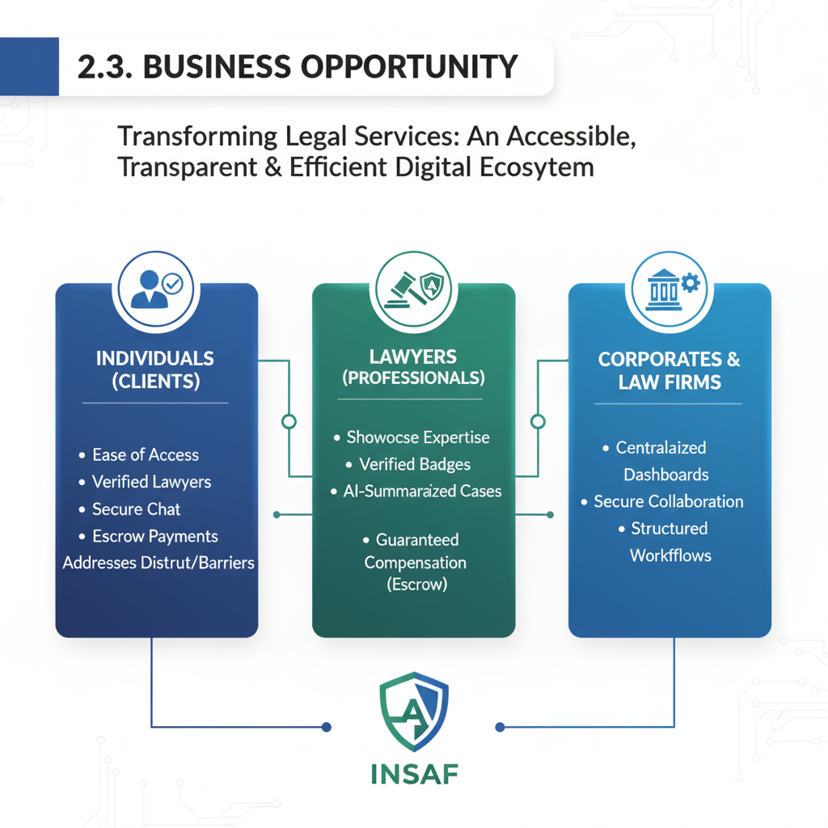
Figure 1 Market Segmentation

2.4. Objectives
The following objective ensures that INSAF functions as a reliable and trustworthy platform for all users seeking legal assistance
1. Accessible & Transparent Justice
The primary objective is to dismantle the barriers hindering access to the legal system in Pakistan, fostering an environment of trust and accessibility.
- Establish a Secure, Centralized Platform: To create a unified digital hub that links clients (individuals and corporates) and law firms directly with legal professionals.
- Ensure Lawyer Verification: To connect users exclusively with verified lawyers. This requires a mandatory process where lawyers upload credentials (e.g., Bar ID, license) for Admin review before receiving a Verified Lawyer Badge.
- Guarantee Financial Security: To implement a protected financial transaction system using escrow-based payments. This ensures fairness and prevents systemic distrust by securely holding client funds until Case Clear Verification is confirmed by both parties.
- Enable Secure Communication: To safeguard user privacy and confidentiality through encrypted communication channels, including end-to-end encrypted text chat and video consultations.
2. AI-Powered Legal Support
The objective is to integrate Artificial Intelligence to enhance productivity, accuracy, and speed for both clients and legal professionals.
- Client Legal Guidance (Law Coach): To integrate the Law Coach AI tool, which provides general legal advice and guidance to clients.
- Professional Assistance (Case Assistants): To integrate Case Assistants (AI advisors) to support lawyers with document analysis, strategic suggestions, and deadline tracking for specific cases.
- Automate Document Intelligence: To use AI tools for processing and condensing legal documents, specifically:
  - OCR-based Text Extraction: To extract text from uploaded documents (e.g., PDFs or images).
  - Auto-Summarization: To condense and summarize documents and client case descriptions (using Pegasus-based summarization).
  - Key Entity Extraction: To identify and display important details such as names, dates, and monetary values from documents.
3. Efficient Case Management
The objective is to streamline the legal workflow, minimize delays, and improve transparency throughout the case lifecycle.
- Streamline Case Assignment: To enable flexible collaboration through AI Context-Based Search to recommend the most relevant lawyers. This supports both a Bidding Mechanism and Direct Assignment to lawyers for Corporations.
- Enable Thread-Based Tracking: To provide a continuous case timeline (thread-based case tracking) for clients and lawyers to view progress and maintain context.
- Provide Automated Reminders: To send timely notifications for hearings, deadlines, and upcoming consultations to all parties, thereby reducing miscommunication and delays.
- Offer Centralized Dashboards: To provide lawyers, corporates, and firms with dashboards for workflows, case tracking, and analytics for effective management of their legal matters

2.5. Scope
The INSAF platform is designed to function as a mobile app-platform solution connecting clients (individuals and corporates) and law firms with verified lawyers in Pakistan. The system focuses on transforming traditional legal services into an accessible, transparent, and efficient digital ecosystem.
The system will include the following core functionalities:

2.5.1 In Scope

Technical Scope
- Verified Lawyer Connection: The system connects individuals and entities with trusted and verified lawyers and displays a badge on their profile.
- AI-Powered Legal Support: Integration of AI tools like Law Coach (general advisor) and Case Assistants (case-specific advisors) for smarter, faster processes.
- Secure Transactions: Implementation of an Escrow Payment System to securely hold client funds until service delivery is confirmed by both client and lawyer.
- Document Intelligence: Utilization of OCR-based text extraction and AI summarization to efficiently process and condense legal documents.
- Case Workflow Management: The system will enable thread-based case tracking, reminders, and analytics dashboards to reduce delays and miscommunication.
- Case Workflow & Opportunity: Allowing lawyers to receive gigs and bid on cases, and manage their professional profiles.
- Secure Communication: Enabling end-to-end encrypted text chat and video consultations.

Non-Technical Scope
- Project Type: INSAF is a secure, centralized mobile app-platform solution for legal services.
- Core Purpose: To link clients with verified lawyers and provide AI-driven assistance to achieve accessible and transparent justice.
- Key Benefit: Guaranteeing security through validated attorney badges, encrypted communication, and escrow-based payments.
- Focus Area: The main focus is on the digital connection and management of legal matters between clients and verified legal professionals in Pakistan.

2.5.2 Out of Scope
- Real-Time Moderation: The system is a post-case completion tool (e.g., ratings are given after case closure); it does not perform live, external moderation or verification of every interaction outside its platform.
- Official Legal Authority: The platform does not replace the official court system and does not provide final legally binding determinations.
- Physical Court Representation: The platform focuses on the digital aspects of legal matter management and does not cover the lawyer's physical representation in court

2.6 Stakeholder and User Description
This section identifies and describes the key stakeholders, target market demographics, user environments, and stakeholder profiles relevant to Insaf. The project involves a diverse set of users and organizations engaged in legal services, digital case management, and justice accessibility.

2.6.1 Market Demographics
Insaf targets a broad range of stakeholders operating within Pakistan’s legal and judicial ecosystem, including:
- Clients and Citizens: Individuals seeking legal advice, representation, or guidance for personal, civil, or criminal cases.
- Lawyers and Legal Practitioners: Independent legal professionals providing verified legal services through the platform.
- Law Firms: Organizations managing multiple lawyers and clients, requiring digital case tracking and document workflows.
- Corporate Clients: Businesses and institutions seeking structured legal support for compliance, contracts, and dispute resolution.
- Regulatory Bodies: Entities such as Bar Councils that verify lawyer credentials and oversee professional ethics.
The platform focuses primarily on urban and semi-urban regions of Pakistan, where digital literacy and smartphone adoption enable widespread usage of mobile applications.

2.6.2 Stakeholder Summary
- Primary Stakeholders:
Clients, lawyers, law firms, and corporate entities directly using the system for case management, communication, and payments.
- Secondary Stakeholders:
Bar Councils, regulatory bodies, and financial service providers indirectly contributing to system verification, compliance, and transactional integrity.

2.6.3 User Environment
Insaf users operate within an online environment designed for secure and efficient legal interactions. The expected environment includes:
- Access through a mobile application (Android, developed using Flutter) connected to a cloud-based backend hosted on AWS, Azure, or GCP.
- Support for real-time communication via encrypted chat and video calls, and document sharing through secure storage.
- Multilingual interface (Urdu and English) to ensure accessibility across Pakistan’s diverse user base.
- Operation under moderate to high-speed internet connectivity to support video consultations, notifications, and real-time data updates.
- Integration of AI-powered features such as OCR, document summarization, and case assistants within a user-friendly dashboard.

2.6.4 Stakeholder Profiles
- Clients and Citizens:
Seek verified legal professionals, transparent communication, and affordable access to justice. Use the system to create cases, track progress, and make secure payments.
- Lawyers:
Use the platform to showcase verified profiles, manage clients, draft legal documents using AI assistants, and conduct secure consultations. Aim to build trust, visibility, and efficiency.
- Law Firms:
Manage multiple lawyers and clients through centralized dashboards, automate workflows, and present firm credentials and success records digitally.
- Corporate Clients:
Utilize the system for managing contracts, compliance documentation, and ongoing legal cases with data transparency and audit trails.
- Regulatory Bodies:
Oversee lawyer verification, ensure ethical compliance, and maintain integrity in the legal services ecosystem.
- System Administrators:
Maintain platform stability, data security, user verification, and regulatory compliance to ensure trustworthy operations.

3. System Requirement Specification
This section outlines the functional and non-functional requirements of the Insaf Legal Services Platform. It defines the system features, performance constraints, and interactions that describe the intended behavior of the platform. The goal is to provide a clear understanding of how the system will operate and meet the needs of its stakeholders, including clients, lawyers, law firms, corporates, and administrators.

3.1 System Features
The Insaf mobile application platform is designed to connect clients (individual and corporate) with verified lawyers through a secure and efficient digital ecosystem. The key features of the system are categorized below.

3.1.1 Core Platform and Trust
Objective: Establish a secure and reliable foundation for interactions between clients, lawyers, and administrators, ensuring identity validation and professional authenticity.
- Secure Authentication: User registration and login via email or CNIC, ensuring a safe and verified entry point into the platform.
- Lawyer Verification: Mandatory process requiring lawyers to upload credentials (e.g., Bar ID, license documents) for Admin review and approval before receiving a Verified Lawyer Badge.
- Profile Management: Lawyers maintain detailed profiles highlighting expertise, service areas, ratings, and achievements.
- Client Favorites: Clients can add trusted lawyers to a Favorites list for quick future case assignments.

3.1.2 Case Assignment and Bidding
Objective: Enable flexible and efficient collaboration between clients and lawyers through AI-based matching, bidding, and direct assignment workflows.
- Case Submission: Clients can submit detailed case descriptions, specifying the area of law and service type.
- AI Context-Based Search: Uses AI to analyze case data and recommend the most relevant lawyers based on specialization and context.
- Bidding Mechanism: Lawyers view available cases and submit proposals with fees and expected timelines; clients can accept, reject, or request new bids.
- Direct Assignment: Clients may bypass bidding and assign cases directly to lawyers from their Favorites list.

3.1.3 Financial and Communication Security
Objective: Ensure secure financial transactions and private communication between clients and lawyers through escrow management and encrypted interaction channels.
- Escrow Payment: Initiates secure collection of 50% of the total agreed fee into escrow upon case assignment.
- Dual-Confirmation Fund Release: Funds are released to the lawyer only after both parties confirm Case Clear Verification.
- Secure Communication: Enables end-to-end encrypted text chat and video consultations using integrated cloud services.

3.1.4 AI-Powered Tools
Objective: Enhance productivity and accuracy in legal case handling through AI-assisted text processing, summarization, and document generation.
- Document Processing: Uses OCR and summarization AI to extract, condense, and identify key entities (names, dates, monetary values) from uploaded documents.
- Legal Document Generation: Generates common legal documents (contracts, affidavits, notices) from templates based on case inputs, prompting users for missing information.
- Supporting AI:
  - Law Coach provides general legal advice to clients.
  - Case Assistant supports lawyers with document analysis, strategic suggestions, and deadline tracking.

3.1.5 Administrative Oversight
Objective: Maintain fairness, compliance, and order through centralized administration and oversight functionalities.
- Dispute Resolution: Allows clients or lawyers to lodge disputes. Admins can review evidence, schedule meetings, resolve cases, and adjust funds accordingly.
- Content Moderation: Admins review and act upon flagged content (e.g., inappropriate reviews or comments) to ensure a professional ecosystem.

3.2 Functional Requirements
The following functional requirements define the essential operational capabilities of the Insaf system, ensuring secure and accessible delivery of digital legal services for all user roles.
- FR1. User Authentication and Profile Management: The system shall allow any User to Authenticate and Manage Profile. The system shall also allow the Admin to manage user data via Manage Users and Update Registered Lawyers.
- FR2. Case Registration and Posting: The system shall allow the Client (both Individual and Corporate) to Register Case and Get Case Assistance detailing their legal needs.
- FR3. Lawyer Recommendation and Search: The system shall provide the ability to Search & Recommend Lawyer to the Client based on case details and allow a Lawyer to View Available Cases.
- FR4. Bidding and Case Acceptance: The system shall allow a Lawyer to Create Bid on available cases. The Client shall be able to Accept Bid, and the Lawyer shall be able to Accept/Reject Cases.
- FR5. AI-Powered Case Assistance: The system shall use an AI component to Generate Summarized Case Card from case details and allow users to Ask Law Coach for contextual suggestions.
- FR6. Secure Communication and Document Sharing: Upon case acceptance, the system shall Create Thread for secure communication, enabling Sharing Messages and allowing participants to Review & Edit Document within the thread.
- FR7. Legal Document Generation: The system shall provide functionality to Generate Legal Document as part of the case workflow.
- FR8. Consultation Booking: The system shall allow the Client to Book Consultation Session with a Lawyer.
- FR9. Escrow Payment Processing: The system shall facilitate secure payment processing, including the ability to Create Escrow, manage Escrow Payment, and Release Escrow upon completion of services or milestones.
- FR10. Lawyer Portfolio and Reviews: The system shall allow a Lawyer to Post Content for their professional portfolio and enable the Client to Give Reviews and Follow Lawyers.
- FR11. Corporate Management Features: The Corporate user shall have specialized functions to Manage Members, Assign Cases to internal teams, and Manage Lawyers associated with their cases.
- FR12. Administrative Oversight and Moderation: The Admin shall have functions to Moderate Content (including bids and lawyer content), Verify Lawyers, and Provides Help and Support to users.
- FR13. System Notifications: The system shall Notify Users of important events such as deadlines, meeting reminders, or case updates.
- FR14. Networking and News Feed: The system shall allow users to Visit News Feed and for Lawyers to Follow Lawyers to build their professional network.
- FR15. Reporting and Analytics: The Admin shall have the ability to View Analytics regarding system usage, case progress, and user statistics.
- FR16. Account Security: Any User shall be able to Block Account for security or privacy reasons.

3.3 Non-Functional Requirements
The following non-functional requirements (NFRs) define the quality attributes and operational constraints for the Insaf platform.
- NFR1. Security (Data Protection and Access): The system must implement strong security measures for Authenticate User, secure the Escrow Payment process, and ensure all communications like Sharing Messages and access to Generate Legal Document are protected via encryption and role-based access control.
- NFR2. Performance (Speed and Responsiveness): The platform must load quickly for critical functions like View Available Cases and Search & Recommend Lawyer and ensure the AI service provides a timely Generate Summarized Case Card.
- NFR3. Reliability (Service Continuity): The system must ensure high availability for core services, including Create Thread, Escrow Payment, and Book Consultation Session, to prevent service disruption.
- NFR4. Scalability (User and Transaction Load): The architecture must be designed to handle simultaneous activity from a large number of Lawyers and Clients, specifically during peak times for Create Bid and Register Case.
- NFR5. Usability (Intuitive Interface): The user interface for processes like Get Case Assistance, Accept Bid, and Manage Members must be intuitive and easy to navigate for non-technical users.
- NFR6. Maintainability (Updatability): The codebase must be structured to allow for easy updates to the Moderate Content rules, the Update Registered Lawyers process, and improvements to the Ask Law Coach feature without significant downtime.
- NFR7. Auditability (Administrative Oversight): The system must log all critical actions, especially financial transactions related to Escrow Payment and administrative decisions like Verify Lawyers and Moderate Content, for future review and auditing purposes.

3.4 System Constraints
Objective: Define operational and technical limitations impacting system design and deployment.
- C1. Platform Dependency: Initially supports Android and iOS mobile applications.
- C2. AI Processing Overhead: Cloud-based OCR and summarization may increase latency.
- C3. Third-Party Dependencies: Reliance on Firebase, AWS Chime, and payment APIs introduces availability risks.
- C4. Verification Dependency: Lawyer validation relies on external Bar Council databases.
- C5. Legal Compliance: Must adhere to Pakistan’s data protection and privacy laws.
- C6. Network Dependency: Requires stable internet connectivity for real-time communication.
- C7. Resource Limitation: Development and testing constrained by a small academic team.

4. Project Artifacts
The following artifacts provide the foundational technical and functional documentation for the Insaf Legal Platform. These documents and diagrams offer a comprehensive, multi-perspective view of the system's architecture, operational behavior, and underlying data flow, transitioning the project from conceptual requirements to a blueprint for implementation.
Each artifact is meticulously developed to serve as a high-fidelity reference point, ensuring clarity, structural consistency, and direct traceability back to the core system requirements. The diagrams in this chapter are instrumental in illustrating key aspects of the system, including:
- User interactions and workflow sequencing (e.g., case posting, bidding, and payment).
- Data processing pathways and component relationships (e.g., AI integration, Escrow/Payment API).
- Structural organization and behavioral design logic (e.g., lawyer verification and content moderation).
- Deployment topology and integration patterns (e.g., cloud storage and Bar Council data sync).
Through these visual models, stakeholders gain a precise understanding of the platform's functional logic and modularity. Critically, these artifacts serve as the primary communication bridge across all project roles—developers, testers, and project managers—facilitating seamless design adherence, informed decision-making, and effective verification that the system successfully fulfils its intended objectives.

4.1 Use Case Diagram

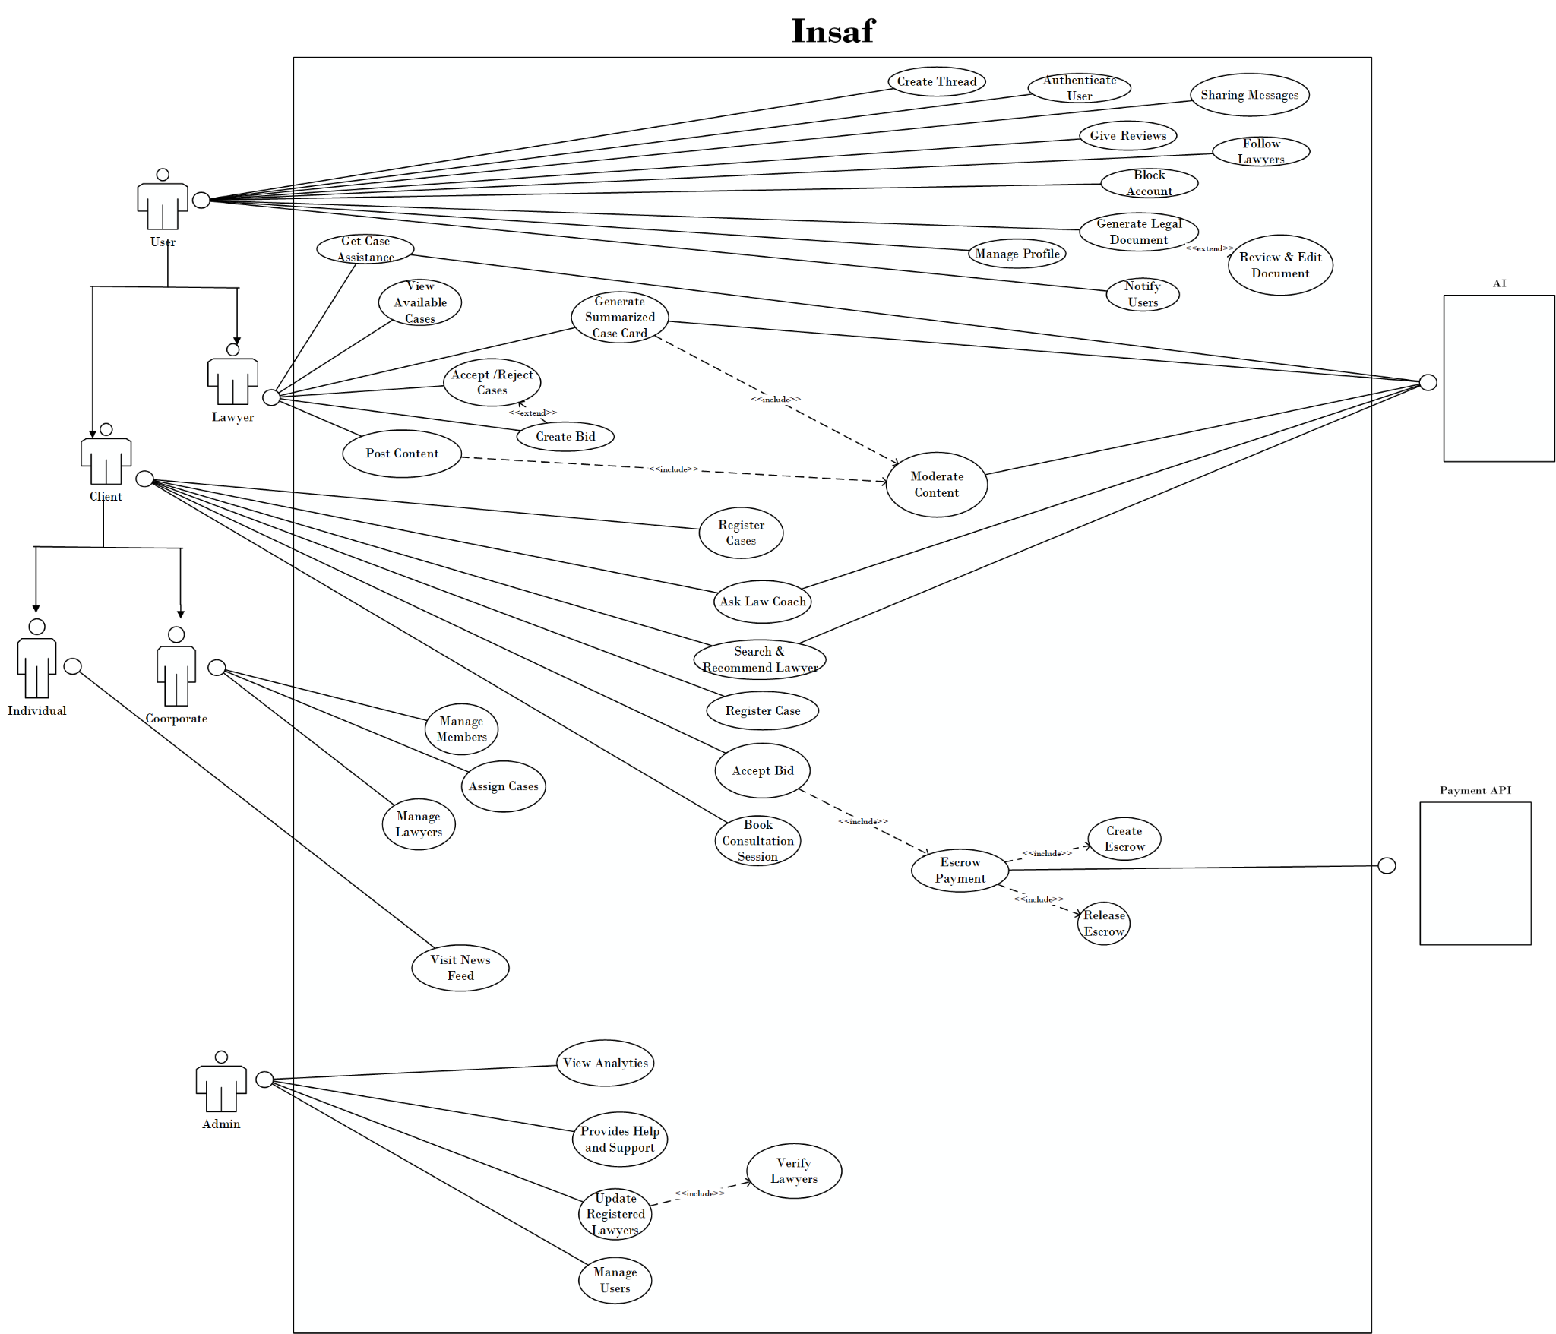
Figure 2: Use Case Diagram of Insaf

4.2 High-Level Use Cases
Section | Content
Use Case ID | UC-01
Name | Authenticate User
Actors | User
Type | Primary
Description | Allows a user (Client or Lawyer) to securely log into the system using registered credentials to access platform features.
Table 1 High Level UseCase: Authenticate User
Section | Content
Use Case ID | UC-02
Name | Manage Profile
Actors | User
Type | Primary
Description | Allows the user to view and update personal profile information such as name, picture, contact details, and preferences.
Table 2: High-Level UseCase: Manage Profile
Section | Content
Use Case ID | UC-03
Name | Create Thread
Actors | User
Type | Primary
Description | Enables a user to start a new discussion thread regarding a legal topic or issue under relevant categories.
Table 3: High-Level UseCase: Create Thread
Section | Content
Use Case ID | UC-04
Name | Notify Users
Actors | User (indirect), System
Type | Secondary (supporting)
Description | Handles sending alerts or notifications to users regarding updates, activities, or interactions relevant to them.
Table 4: High-Level UseCase: Notify Users
Section | Content
Use Case ID | UC-07
Name | Block Account
Actors | User
Type | Primary
Description | Allows a user to temporarily or permanently block others account to prevent interaction with them on the platform.
Table 5: High-Level UseCase: Block Account
Section | Content
Use Case ID | UC-08
Name | Give Reviews
Actors | User
Type | Primary
Description | Enables a user to provide ratings and written reviews for lawyers based on consultation or case handling experience.
Table 6: High-Level UseCase: Give Reviews
Section | Content
Use Case ID | UC-09
Name | Follow Lawyers
Actors | User
Type | Primary
Description | Allows a user to follow one or more lawyers to receive updates on their posts, activities, and shared legal content.
Table 7: High-Level UseCase: Follow Lawyers
Section | Content
Use Case ID | UC-10
Name | Share Messages
Actors | User
Type | Primary
Description | Enables a user to share chat messages, posts, or case-related updates with lawyers through the platform’s messaging or sharing feature.
Table 8: High-Level UseCase: Share Messages
Section | Content
Use Case ID | UC-11
Name | Get Case Assistance
Actors | Lawyer, AI
Type | Primary
Description | Allows a lawyer to receive AI-powered assistance such as case analysis, legal suggestions, document insights, or reference material to support case preparation.
Table 9: High-Level UseCase: Get Case Assistance
Section | Content
Use Case ID | UC-12
Name | View Available Cases
Actors | Lawyer
Type | Primary
Description | Enables a lawyer to browse a list of open or posted cases that require legal assistance, along with details to decide suitability.
Table 10: High-Level UseCase: View Available Cases
Section | Content
Use Case ID | UC-18
Name | Assign Case
Actors | Corporate
Type | Primary
Description | Enables an organization to assign a legal case to a selected lawyers that are working with the organization. This action officially links the lawyer to the Respective case.
Table 11: High-Level UseCase: Assign Case
Section | Content
Use Case ID | UC-19
Name | Ask Law Coach
Actors | Client, AI
Type | Primary
Description | Allows a client to ask legal queries from the AI Law Coach and receive guidance, FAQs, legal steps, rights information, or recommended next actions based on user context.
Table 12: High-Level UseCase: Ask Law Coach
Section | Content
Use Case ID | UC-20
Name | Search & Recommend Lawyer
Actors | Client, AI
Type | Primary
Description | Enables a client to search for lawyers using filters (location, expertise, price, language, ratings), after which the AI recommends the most suitable lawyers based on case type and user preferences.
Table 13: High-Level UseCase: Search & Recommend Lawyer
Section | Content
Use Case ID | UC-21
Name | Register Case
Actors | Client
Type | Primary
Description | Allows a client to register a new legal case by submitting case details, selecting category, adding documents, and creating a case record to be visible to assigned or interested lawyers.
Table 14: High-Level UseCase: Register Case

Section | Content
Use Case ID | UC-22
Name | Book Consultation Session
Actors | Client
Type | Primary
Description | Allows a client to book a legal consultation session with a selected lawyer by choosing available time slots and confirming booking details.
Table 15: High-Level UseCase: Book Consultation Session
Section | Content
Use Case ID | UC-27
Name | Manage Members
Actors | Corporate
Type | Primary
Description | Allows a corporate account to add, remove, and manage internal team members who will access the legal platform on behalf of the organization. Includes setting member roles and permissions.
Table 16: High-Level UseCase: Manage Members
Section | Content
Use Case ID | UC-28
Name | Manage Lawyers
Actors | Corporate
Type | Primary
Description | Enables corporate users to assign, remove, and manage lawyers working on the organization’s legal matters, including performance viewing and lawyer switching for cases.
Table 17: High-Level UseCase: Manage Lawyers
Section | Content
Use Case ID | UC-29
Name | Visit News Feed
Actors | User
Type | Primary
Description | Allows any user to view the news feed showing legal posts, announcements, updates, lawyer content, and community interactions.
Table 18: High-Level UseCase: Visit News Feed

Section | Content
Use Case ID | UC-30
Name | View Analytics
Actors | Admin
Type | Primary
Description | Allows the admin to view system analytics such as user growth, platform performance, case statistics, lawyer activity, and engagement metrics.
Table 19: High-Level UseCase: View Analytics
Section | Content
Use Case ID | UC-31
Name | Provide Help and Support
Actors | Admin
Type | Primary
Description | Enables the admin to assist users by responding to queries, resolving disputes, and providing platform-related support.
Table 20: High-Level UseCase: Provide Help and Support
Section | Content
Use Case ID | UC-32
Name | Manage Users
Actors | Admin
Type | Primary
Description | Allows the admin to manage platform users, including blocking/unblocking accounts, resolving conflicts, and enforcing community guidelines.
Table 21: High-Level UseCase: Manage Users

4.3 Use Case Specifications
Section | Content
Use Case ID | UC-05
Name | Generate Legal Document
Actors | User
Type | Primary
Description | Allows a user to generate a legal document using predefined templates or AI-assisted inputs. The system produces a draft document for the user.
Trigger Event | User selects “Generate Document” option from the app.
Pre-conditions | 1. User must be logged in.  2. User must have access permission to document generation feature.
Post-condition | 1. Legal document draft is generated and stored.  2. User may proceed to review/edit the document (UC-06).
Main Scenario | 1. User selects “Generate Legal Document”.  2. System displays list of legal document types (e.g., Agreement, Affidavit, Complaint).  3. User selects a document type.  4. System prompts for required details through form or structured questions.  5. User provides required inputs and submits.  6. System validates inputs.  7. System generates a draft document based on templates and user data.  8. System saves the draft and displays it to the user.
Alternative Scenarios | 3a. Template Not Found: System displays “Document type currently unavailable.”  5a. Auto-Fill: User selects auto-fill using saved profile details.
Exception Scenarios | 6a. Missing Required Fields: System highlights missing fields before proceeding.  7a. Document Generation Error: System shows “Error generating document, try again.”
Result | Draft legal document is generated successfully and ready for review.
Table 22: The Use Case Specification for UC-05 (Generate Legal Document)

Section | Content
Use Case ID | UC-06
Name | Review & Edit Document
Actors | User
Type | Secondary
Description | Enables the user to review, modify, and finalize the draft document generated in UC-05 before saving, printing, or sharing it.
Trigger Event | User chooses to review or edit the generated document.
Pre-conditions | 1. A document must be generated (UC-05 completed).
Post-condition | 1. Updated and finalized document version is saved.
Main Scenario | 1. User opens the generated draft document.  2. System displays the document in editing mode.  3. User reviews and edits text sections as needed.  4. User saves changes.  5. System validates structure and formatting.  6. System stores the updated version.  7. System confirms “Document Updated Successfully”.
Alternative Scenarios | 3a. Revert to Original: User selects “Undo changes”, System restores initial draft.  4a. Save as New Version: System stores a new version while keeping original.
Exception Scenarios | 5a. Invalid Format Edit: System highlights formatting issue and suggests correction.  6a. Save Failure: System shows “Unable to save changes, try again.”
Result | User successfully finalizes the document with edits applied.
Table 23: The Use Case Specification for UC-06 (Review & Edit Document)

Section | Content
Use Case ID | UC-13
Name | Accept/Reject Cases
Actors | Lawyer
Type | Secondary
Description | Allows a lawyer to accept or reject a case after reviewing the client details and bid requirements.
Trigger Event | Lawyer views a case that requires action.
Pre-conditions | Case is visible to lawyer; Lawyer is verified.
Post-condition | Case is either accepted for bidding or rejected.
Main Scenario | 1. Lawyer reviews case details.  2. Lawyer selects “Accept” or “Reject.”  3. System records decision.  4. If accepted, System allows lawyer to proceed to Create Bid (UC-14).
Alternative Scenarios | 2a. Lawyer requests more information from client before deciding.
Exception Scenarios | 1a. Case no longer available, System shows status update.
Result | Case action completed; may proceed to bid creation.
Table 24: The Use Case Specification for UC-06 (Accept/Reject Cases)

Section | Content
Use Case ID | UC-14
Name | Create Bid
Actors | Lawyer
Type | Primary
Description | Enables a lawyer to create and submit a bid for a case posted by a client, including proposed fee, timeline, and work plan.
Trigger Event | Lawyer selects “Place a Bid” on an available case.
Pre-conditions | Lawyer is verified and logged in; Case is open for bidding.
Post-conditions | Bid is submitted and visible to the client for review.
Main Scenario | 1. Lawyer opens case details.  2. Lawyer selects “Create Bid.”  3. System displays bid form.  4. Lawyer enters bid amount, timeline, and proposal.  5. System validates input.  6. System submits bid to client.
Alternative Scenarios | 5a. Lawyer saves bid as draft.
Exception Scenarios | 5b. Invalid or incomplete bid, System shows error.  6a. Network failure, System retries or saves locally.
Result | A valid bid is submitted for client action.
Table 25: The Use Case Specification for UC-14 (Create Bid)

Section | Content
Use Case ID | UC-15
Name | Generate Summarized Case Card
Actors | Lawyer, AI
Type | Primary
Description | Allows a lawyer to generate a summarized case card using AI for quick case understanding or sharing.
Trigger Event | Lawyer selects “Generate Case Summary.”
Pre-conditions | Case data is available in system.
Post-conditions | Summary card is generated and validated.
Main Scenario | 1. Lawyer selects case.  2. System fetches case details.  3. AI generates summary card.  4. System performs content moderation (UC-16).  5. Summary is saved and ready to share.
Alternative Scenarios | 3a. Lawyer edits AI summary before finalizing.
Exception Scenarios | 3b. AI fails, System offers manual summary template.
Result | A moderated and publish-ready case summary card is generated.
Table 26: The Use Case Specification for UC-15 (Generate Summarized Case Card)

Section | Content
Use Case ID | UC-16
Name | Moderate Content
Actors | Lawyer, AI
Type | Secondary
Description | Ensures uploaded or generated content is legally appropriate, free of hate, spam, or misinformation before publishing.
Trigger Event | User attempts to publish or generate legal content.
Pre-conditions | Content submitted for review.
Post-conditions | Content is either approved, flagged, or rejected.
Main Scenario | 1. Content is submitted.  2. AI checks for legal and ethical compliance.  3. System approves content.
Alternative Scenarios | 2a. AI flags content.
Exception Scenarios | 3a. Content violates policy, System rejects and suggests revisions.
Result | Only safe and valid content is approved.
Table 27: The Use Case Specification for UC-16 (Moderate Content)

Section | Content
Use Case ID | UC-17
Name | Post Content
Actors | Lawyer
Type | Primary
Description | Allows a lawyer to post legal content such as tips, news, case studies, or videos on the platform feed.
Trigger Event | Lawyer selects “Create Post.”
Pre-conditions | Lawyer logged in; content ready.
Post-conditions | Post is published on feed.
Main Scenario | 1. Lawyer selects post type (text/image/video).  2. Lawyer composes post.  3. System runs content moderation (UC-16).  4. System publishes content.
Alternative Scenarios | Save post as draft.
Exception Scenarios | AI flags, Lawyer must edit or delete.
Result | Approved content becomes visible to users.
Table 28: The Use Case Specification for UC-17 (Post Content)

Section | Content
Use Case ID | UC-23
Name | Accept/Reject Bid
Actors | Client
Type | Primary
Description | Allows a client to accept a lawyer’s bid for a case, perform verification, initiate escrow payment, and proceed towards case assignment.
Trigger Event | Client selects “Accept Bid” from the list of received bids.
Pre-conditions | 1. Client must be logged in.  2. At least one bid must exist for the case.
Post-conditions | 1. Lawyer is hired and assigned to the case.  2. Escrow payment is created and locked.  3. Case is now in active working state.
Main Scenario | 1. Client reviews submitted bids.  2. Client selects “Accept Bid.”  3. System triggers UC-24 (OTP Verification).  4. Upon success, system invokes UC-25 (Create Escrow).  5. System assigns lawyer to the case.  6. Once case work is completed and confirmed by client, UC-26 (Release Escrow) is executed.  7. System notifies both parties and updates status.
Alternative Scenarios | 3a. OTP Failed (UC-24): User enters wrong OTP, System denies acceptance.  4a. Payment Failed (UC-25): Escrow creation fails, System shows “Payment Failed. Try Again” and bid remains pending.  1a. Client Cancels: Client exits without accepting, No action taken.
Exception Scenarios | 4b. Payment Service Down: System unable to create escrow, Process paused until service resumes.
Result | Lawyer is successfully hired, escrow is created, and the case engagement formally begins.
Table 29: The Use Case Specification for UC-23 (Accept/Reject Bid)

Section | Content
Use Case ID | UC-24
Name | Escrow Payment
Actors | Client, Payment API
Type | Primary
Description | Handles secure payment processing through the escrow system, ensuring funds are held safely until case milestones are completed and approved by the client.
Trigger Event | Triggered when a client proceeds with bid acceptance requiring payment.
Pre-conditions | 1. Client must be logged in.  2. Valid payment method must exist.  3. Associated bid must be selected for acceptance.
Post-conditions | 1. Payment request is verified and processed.  2. System is ready to create escrow (UC-25).
Main Scenario | 1. System prompts client to confirm escrow payment.  2. Client reviews and confirms payment.  3. System sends transaction request to Payment API.  4. Payment API validates payment details and authorizes the transaction.  5. System prepares details for escrow creation (UC-25).
Alternative Scenarios | 2a. Client changes payment method: Client selects “Change Payment Method”, System allows updating payment details.  3a. Client cancels transaction: Payment request discarded, and process stops without escrow.
Exception Scenarios | 4a. Payment Rejected: Payment API declines transaction, System shows “Payment Failed. Try another method.”  4b. API Timeout/Error: System retries once, then shows “Payment Service Unavailable. Try later.”
Result | Payment is verified and authorized, enabling escrow creation.
Table 30: The Use Case Specification for UC-24 (Escrow Payment)

Section | Content
Use Case ID | UC-25
Name | Create Escrow
Actors | Client, Payment API
Type | Secondary
Description | Creates a secure escrow by locking client funds when a bid is accepted, ensuring payment safety until the case work is completed.
Trigger Event | Client accepts a lawyer’s bid for a case.
Pre-conditions | 1. Client must be logged in.  2. Valid payment method must be available.  3. Bid must be approved and active.
Post-conditions | 1. Escrow is successfully created and funds are locked.  2. Transaction is recorded and visible to both parties.
Main Scenario | 1. Client selects an approved bid.  2. System prompts client to confirm escrow payment.  3. Client confirms payment details.  4. System sends payment request to Payment API.  5. Payment API validates and authorizes the transaction.  6. System creates an escrow and locks the funds.  7. System notifies Client and Lawyer of successful escrow creation.
Alternative Scenarios | 4a. Payment Declined: Payment API rejects transaction. System notifies client with “Payment Failed. Try another method.”  3a. User Cancels Payment: Client cancels payment during confirmation, Process terminates without escrow.
Exception Scenarios | 5a. API Timeout/Failure: Payment API not responding, System retries once and shows “Payment Service Unavailable. Try again later.”
Result | Escrow is created and funds are securely locked until the case is completed.
Table 31: The Use Case Specification for UC-25 (Create Escrow)

Section | Content
Use Case ID | UC-26
Name | Release Escrow
Actors | Client, Payment API
Type | Secondary
Description | Releases the escrowed funds to the lawyer once the client confirms successful completion of case work.
Trigger Event | Client marks case work as completed/approved.
Pre-conditions | 1. Client must be logged in. 2. Escrow must already exist. 3. Case must be completed and awaiting payment release.
Post-conditions | 1. Funds are released from escrow to the lawyer. 2. Transaction receipt is generated and stored.
Main Scenario | 1. Client opens the case summary.  2. Client selects “Mark as Completed.”  3. System requests confirmation for releasing escrow.  4. Client confirms release.  5. System sends release request to Payment API.  6. Payment API validates request and transfers funds to the lawyer.  7. System updates case status to “Completed” and notifies both parties.
Alternative Scenarios | 4a. Client Requests Revision: Client selects “Request Changes”, Escrow remains locked and lawyer is notified.
Exception Scenarios | 6a. API Failure/Timeout: Payment API fails to release funds, System logs failure and displays: “Payment Service Error. Release attempt failed.”
Result | Escrow funds are released to the lawyer and payment is successfully completed.
Table 32: The Use Case Specification for UC-26 (Release Escrow)

Section | Content
Designation | UC-33
Name | Update Registered Lawyers
Actors | Admin
Type | Primary
Description | Enables the Admin to view, edit, and update registered lawyer profiles (contact, specialization, license info), trigger re-verification, and change verification status or visibility of a lawyer on the platform.
Trigger Event | Admin selects a lawyer record to update or initiates a bulk update / re-verification process.
Pre-conditions | 1. Admin is authenticated and authorized.  2. Lawyer account exists in the system.
Post-conditions | 1. Lawyer record updated.  2. Verification status updated if Verify Lawyers (UC-34) executed.  3. Audit trail entry created for the change.
Main Scenario | 1. Admin navigates to the “Registered Lawyers” management screen.  2. Admin selects a lawyer record to view details.  3. System displays current lawyer profile, credentials, and verification status. 4. Admin edits required fields (e.g., contact info, specialization, fees, status). 5. If credentials changed or verification stale, Admin triggers Verify Lawyers (UC-34).  6. System receives verification result and updates the lawyer’s verification badge/status.  7. Admin saves changes.  8. System logs the update in the audit trail and notifies the lawyer of changes.
Alternative Scenarios | 4a. Bulk Update: Admin uploads CSV to update multiple lawyer records, System validates and applies batch updates.  5a. Manual Note: Admin adds an internal note or places the lawyer on “Pending Verification” while awaiting documents.
Exception Scenarios | 3a. Record Not Found: Selected lawyer record was deleted by another admin, System displays “Record not available.”  5b. Verification API Down: UC-34 fails due to Bar Council API downtime, System marks status “Verification Pending” and queues retry.  7a. Invalid Update: Input validation fails (e.g., invalid license format), System rejects save and highlights fields.
Result | Registered lawyer profile is updated; verification status is current and an audit record exists for traceability.
Table 33: The Use Case Specification for UC-33 (Update Registered Lawyers)
Section |  | Content
Designation |  | UC-34
Name |  | Verify Lawyers
Actors |  | Admin, External Service
Type |  | Secondary
Description |  | Validates a lawyer’s professional credentials (license number, registration status) against the official Bar Council database or via manual document verification, and updates the platform verification badge and status accordingly.
Trigger Event |  | Admin requests verification for a specific lawyer, or system schedules periodic verification (e.g., quarterly sync).
Pre-conditions |  | 1. Lawyer record contains license number and required documents. 2. Admin is authenticated and authorized to perform verification.
Post-conditions | 1. Verification status updated (Verified / Unverified / Pending / Rejected). 2. Verification evidence and timestamp stored in audit logs.
Main Scenario |  | 1. Admin initiates verification for a lawyer (manually or via batch).  2. System sends a verification request to the BarCouncilAPI (or calls internal verification workflow).  3. External Service responds with match result (Verified / Not Found / Suspended).  4. If Verified, System updates lawyer status to Verified, displays verified badge, and records verification metadata.  5. If Not Found or Suspended, System marks status Unverified/Pending, flags record for manual review, and notifies Admin to request further documents.  6. Admin may perform manual verification by reviewing uploaded documents and updating status accordingly.  7. System logs the verification outcome and notifies the lawyer of the result.
Alternative Scenarios |  | 2a. Local Cache Match: System uses cached Bar Council data when external API latency is high and flags for later recheck.  6a. Manual Escalation: Complex cases are escalated to a senior Admin or compliance officer for a final decision.
Exception Scenarios |  | 2b. API Timeout / Error: Bar sCouncil API returns an error, System retries per backoff policy; if still failing, sets status to Verification Pending and alerts Admin.  4a. Data Mismatch / Fraud: Returned data does not match uploaded documents, System marks as Rejected, suspends the account (if risk rules match), and escalates to Admin for investigation.
Result |  | Lawyer’s verification status (Verified / Unverified / Pending / Rejected) is recorded; associated evidence and audit logs are stored for compliance and future audits.
Table 34: The Use Case Specification for UC-34 (Verify Lawyers)

4.4 Activity Diagram
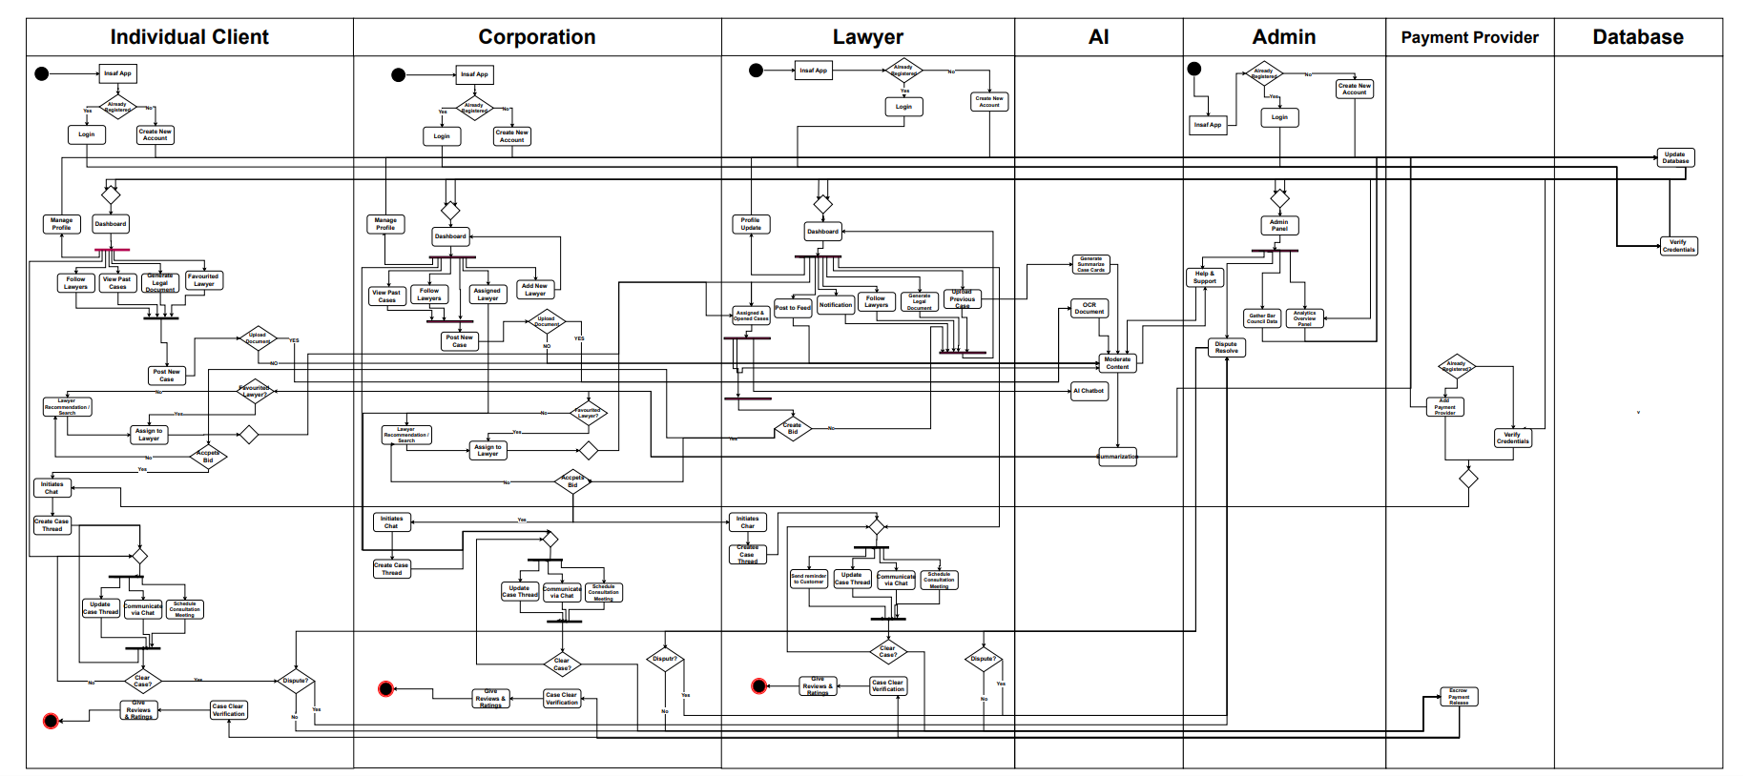
Figure 3: The Activity Diagram illustrates the comprehensive workflow for the Insaf Legal Platform

4.5 System Sequence Diagrams(SSD)
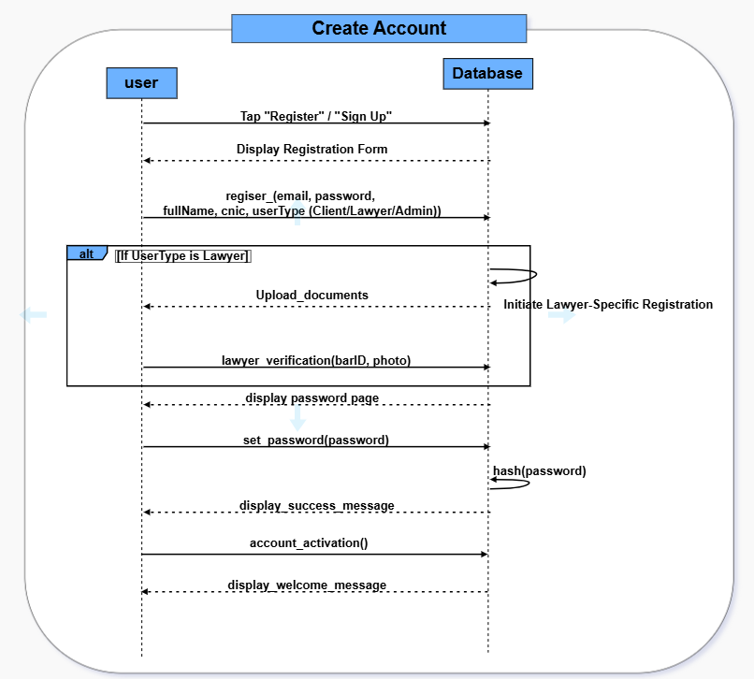
Figure 4: SSD–Create Account

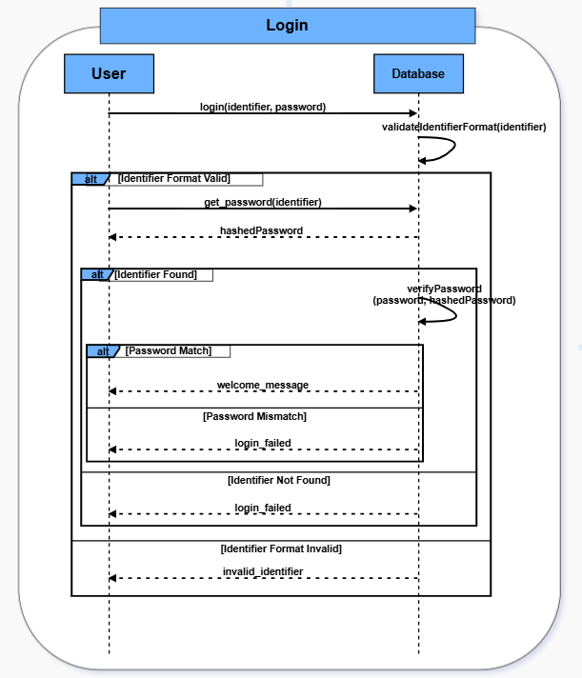
Figure 5: SSD–Login

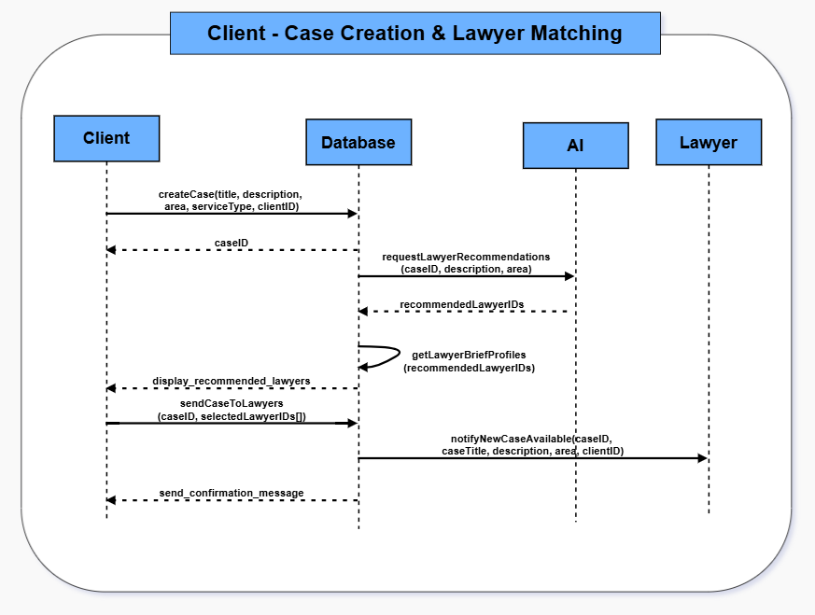
Figure 6: SSD–Case Creation & Lawyer Matching

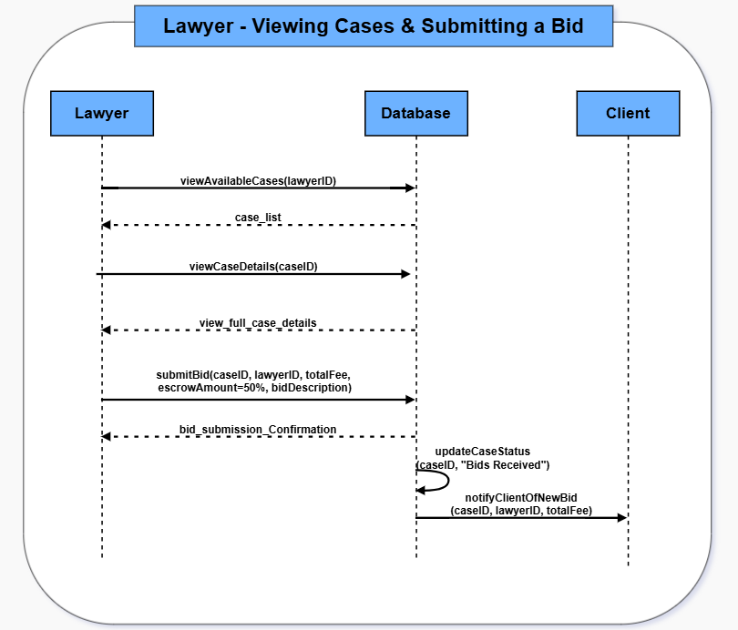
Figure 7: SSD–Viewing Cases & Submitting a Bid

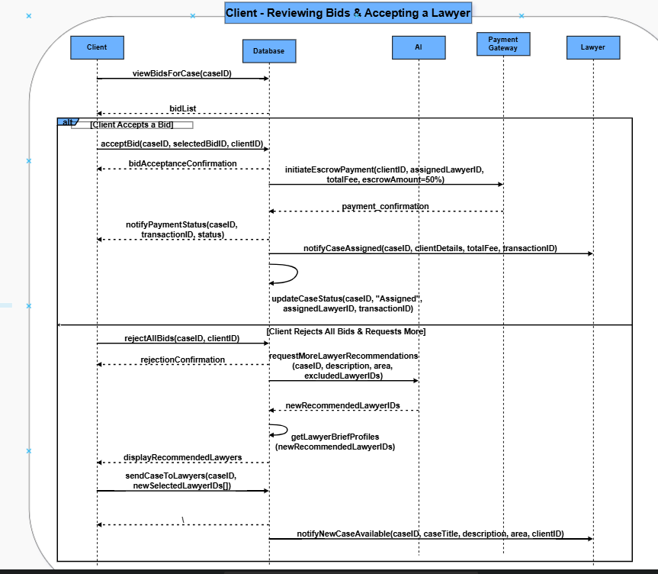
Figure 8: SSD–Reviewing Bids & Accepting a Lawyer

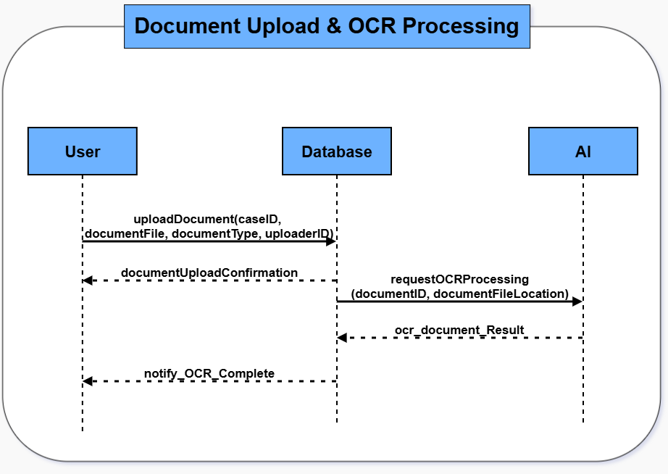
Figure 9: SSD–Document Upload & OCR Processing

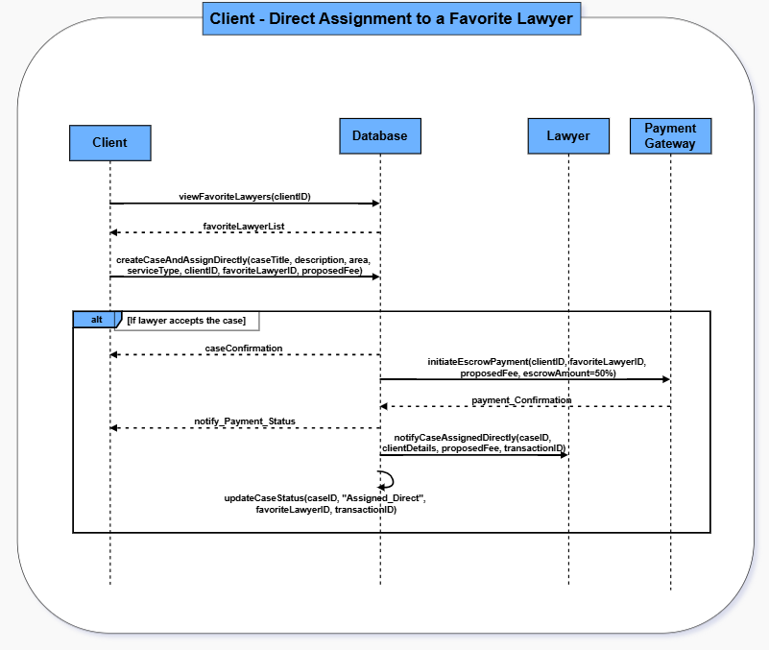
Figure 10: SSD– Direct Assignment to a Favorite Lawyer

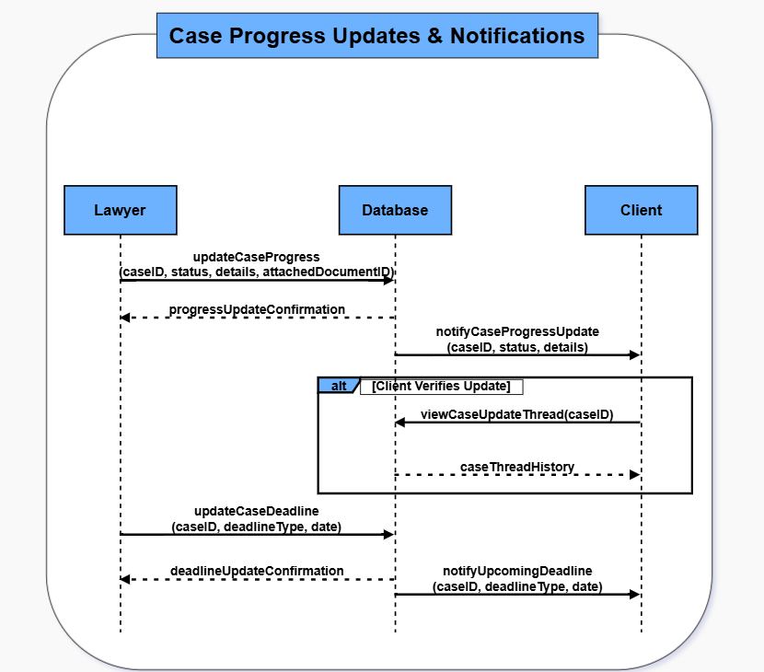
Figure 11: SSD- Case Progress Updates & Notifications

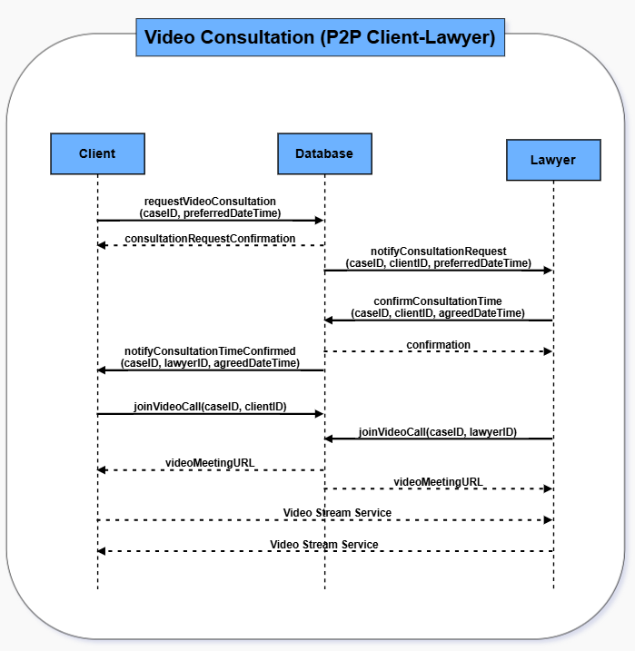
Figure 12: SSD–Vedio Consultation (P2P Client-Lawyer)

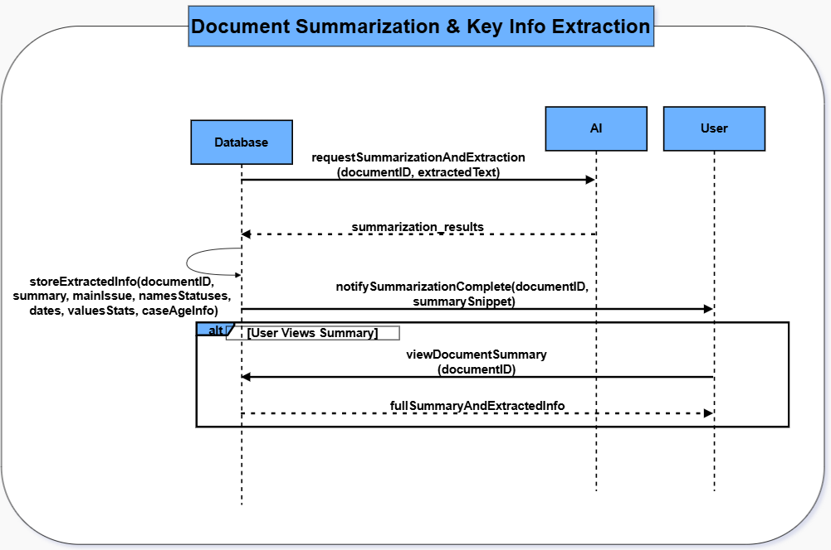
Figure 13: SSD–Document Summarization & Key Info Extraction

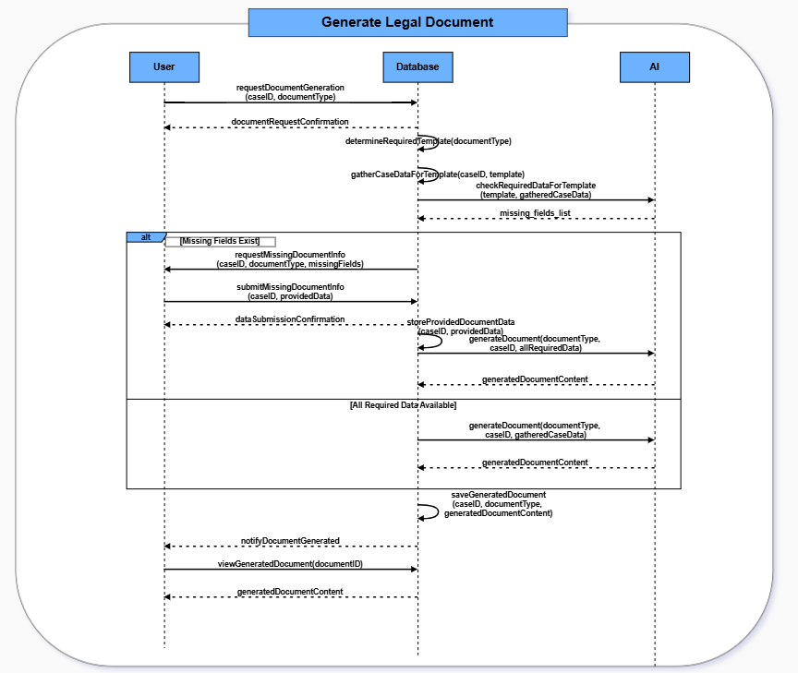
Figure 14: SSD–Generate Legal Document

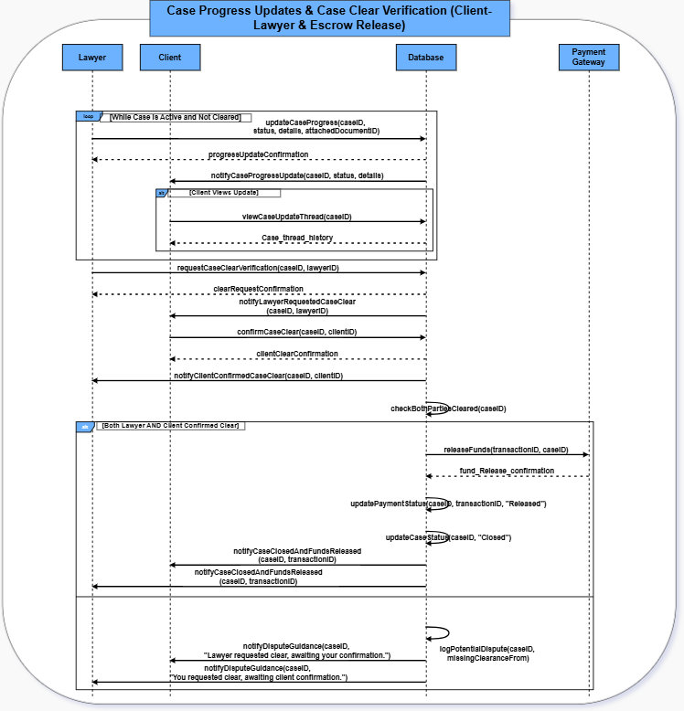
Figure 15: SSD–Case Progress Updates & Case-Clear Verification (Client-Lawyer & Escrow Release)

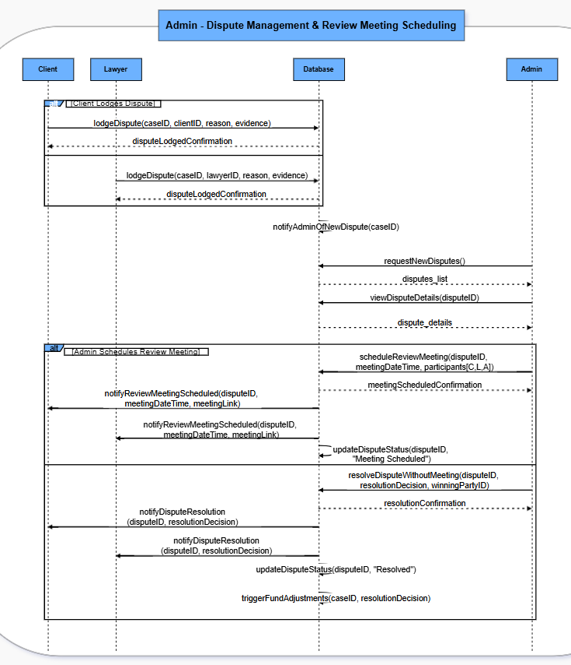
Figure 16: SSD–Admin-Dispute Management & Review meeting Sceduling

4.6 Process Flow Diagram
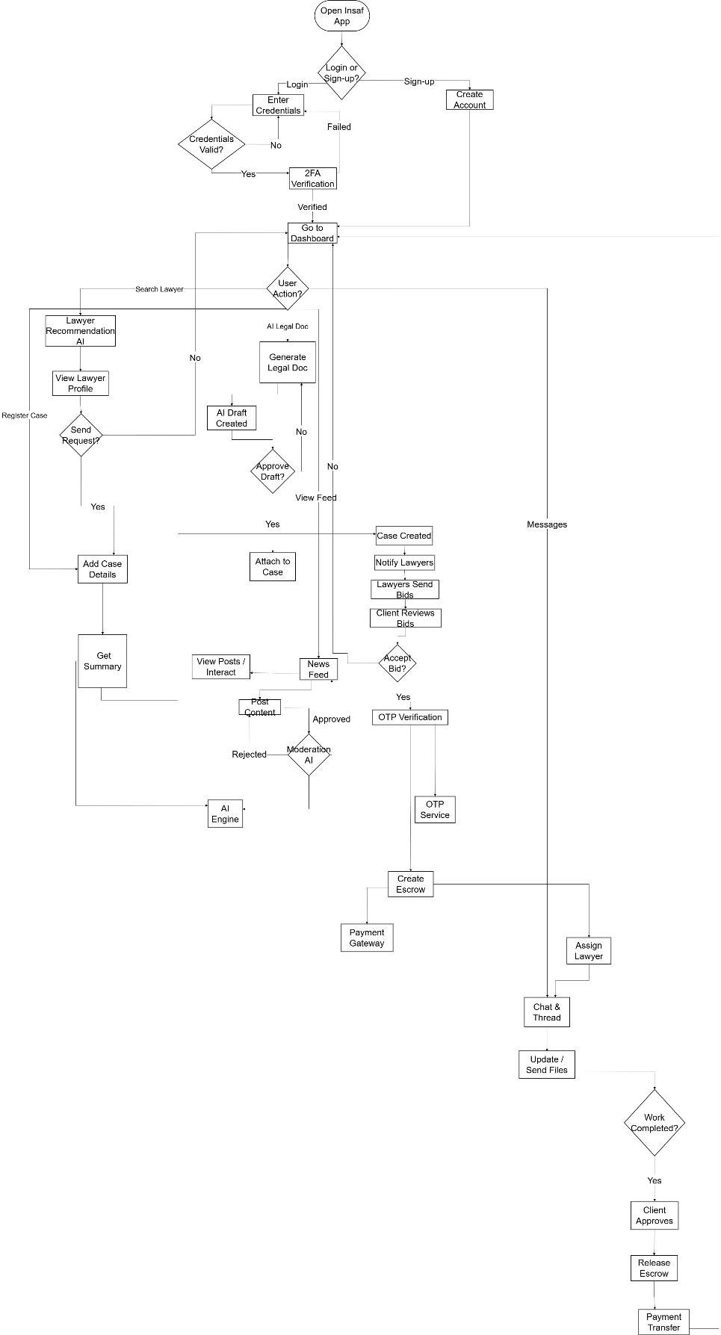
Figure 17: The Process Flow Diagram provides a detailed, granular visualization of the core operational logic for the Insaf platform

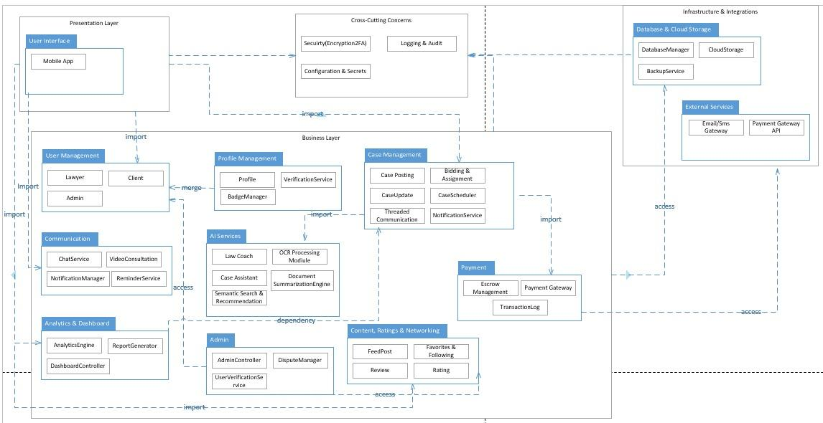
4.6 Package Diagram

Figure 18: The Package Diagram illustrates the high-level architecture of the Insaf system by grouping related functionalities into logical packages

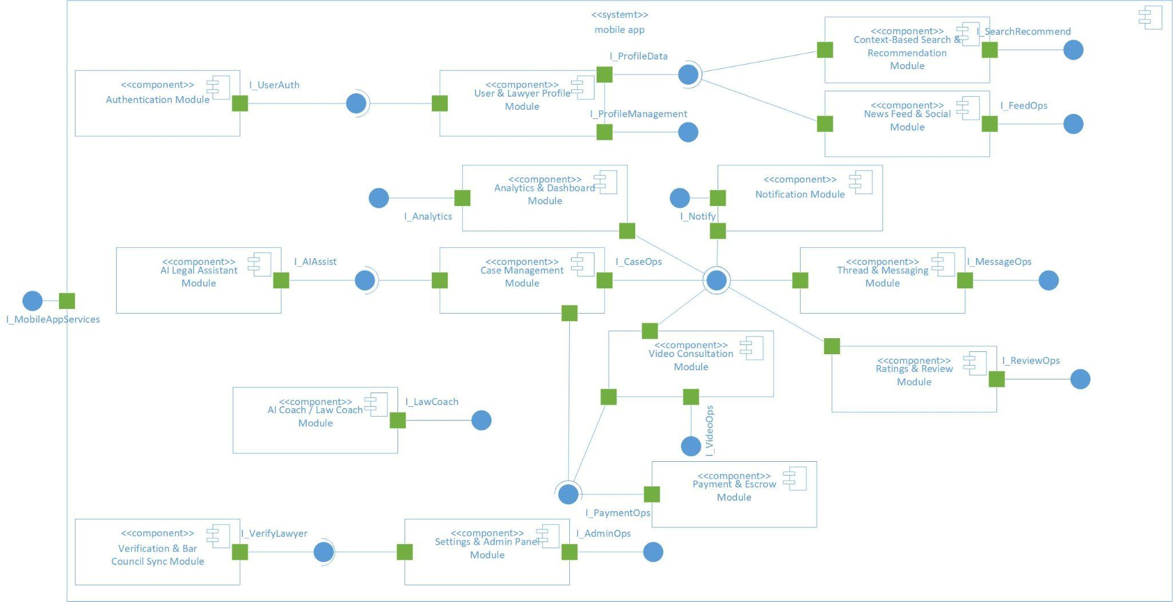
4.7 Component Diagram

Figure 19: The Component Diagram presents the modular, implementation-level structure of the Insaf mobile application and its backend services

4.7 JSON Tree Diagram
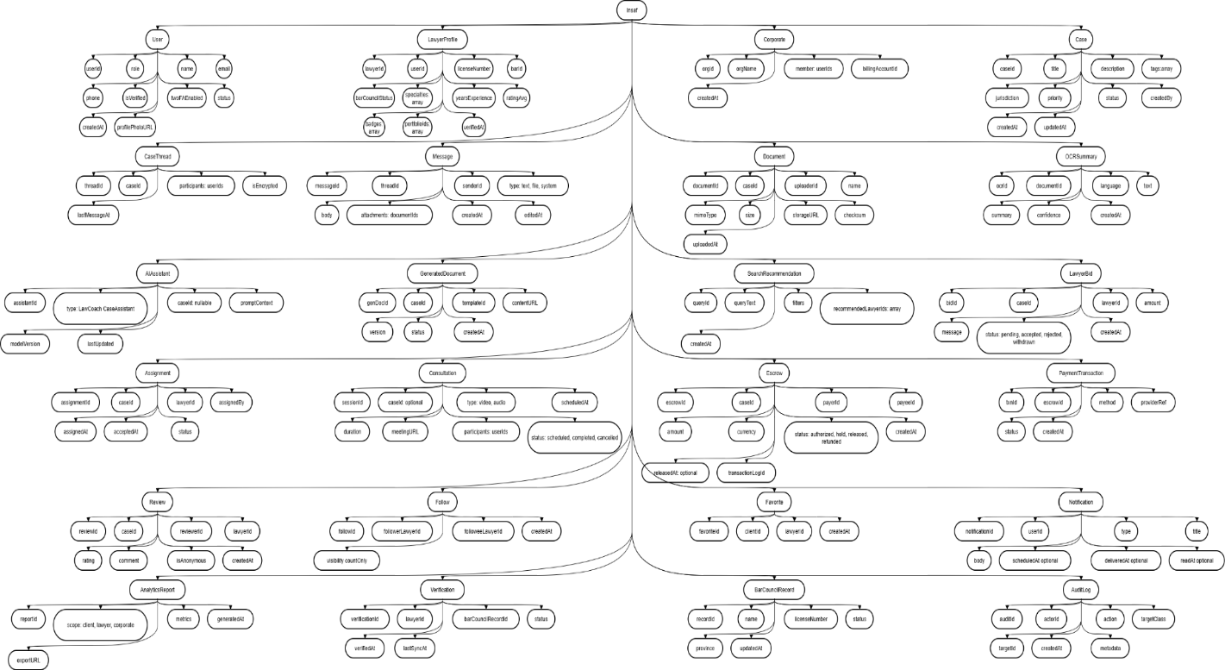

Figure 20: The JSON Tree Diagram (Abstract) provides a high-level, structural overview of the data objects and messaging formats used within the Insaf system

4.7.2. Json Tree Diagram
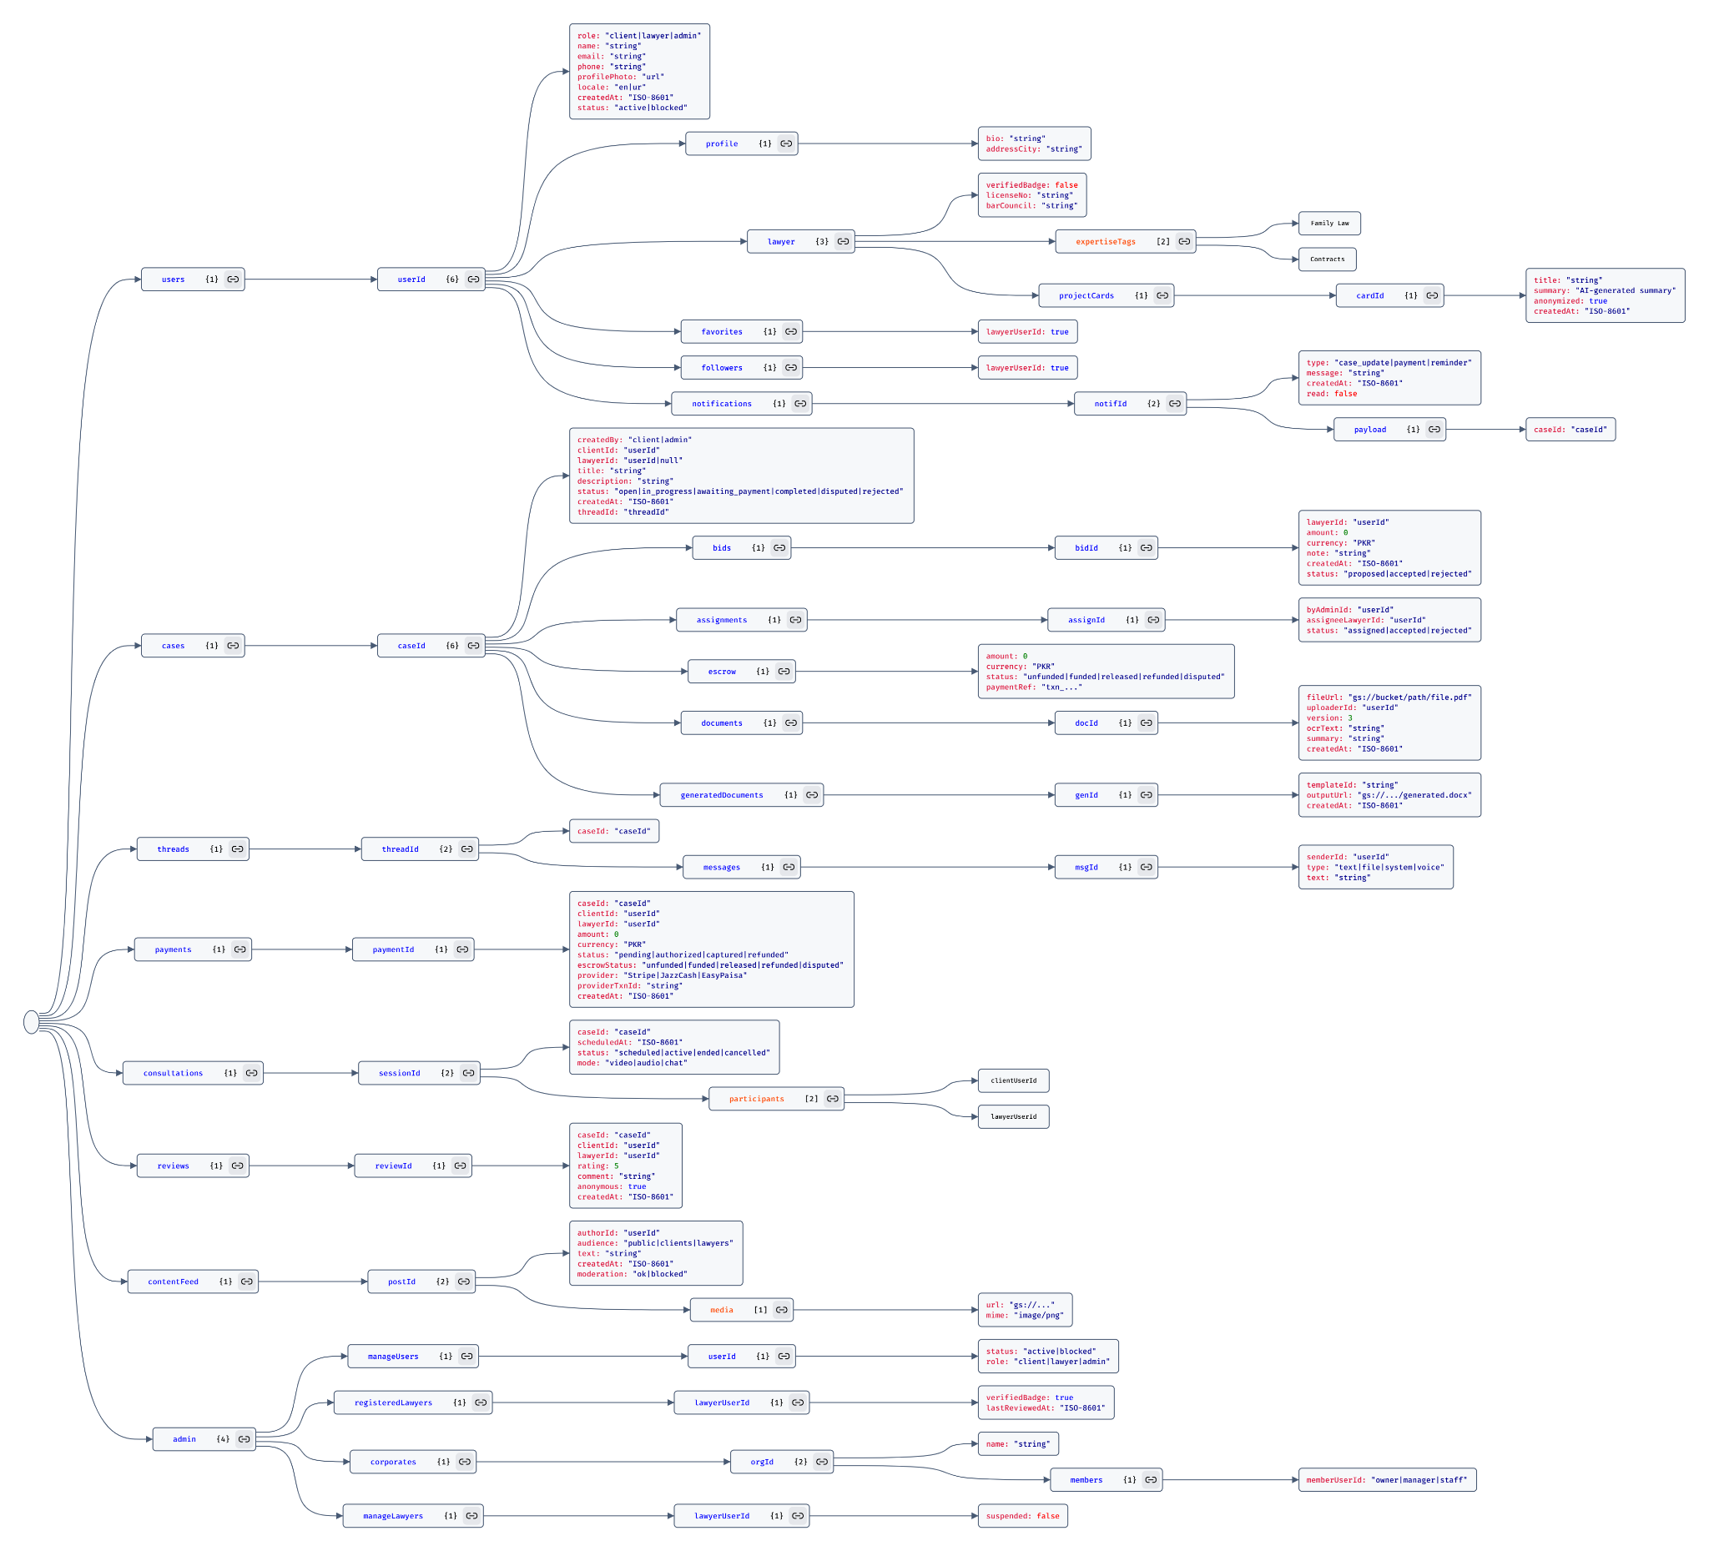
Figure 21: The JSON Tree Diagram (Detailed) represents the precise schema and field definitions for the Insaf system's primary data models

